Market Demand Assessment for Smart Pen
Step 1: Decide the best general search query for products that would be in competition with us.
After testing different key words involving the smart pen, we discovered that the word search that resulted in the most items returned was “Smartpen”; we found 22 products that match this search query. We decided this was the best query because it resulted in the most results directly related to our new product, and we want to be able to use the largest sample to compare the prices and other information about our competitors. We also considered queries such as “smart pen”, “Smart pen”, “Smart Pen”, and “Smart Notebook”, but they did not have as many product results as our best query key word.
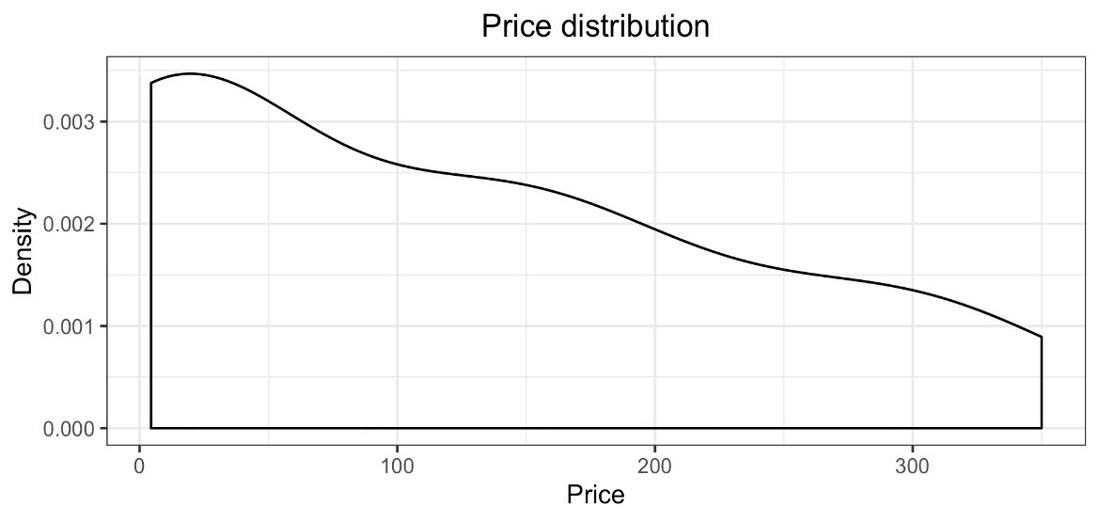
The price distribution does not follow a normal trend and instead is skewed towards the left; as price increases, the number of products available falls. This is likely because given there are multiple similar products on the market, competitive pricing will lower the price. In addition, the average price that customers are willing to pay for this product may be on the lower side but it might also have a larger confidence interval which accounts for the products succeeding at higher prices.

Market position of competitors product
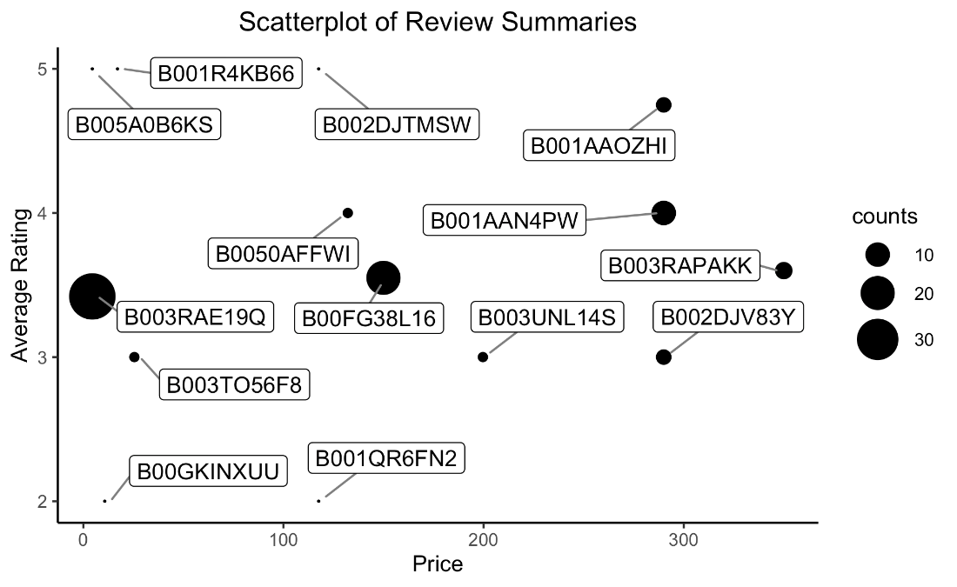
We noticed in the scatterplot that price varies significantly across products but most products have average ratings between 3 and 4. There is greater variability in average rating among the lower priced products, while higher priced products are all above an average 3 stars. Though there are highly rated outliers at low prices, we believe that these are less reliable to study because of their limited count of reviews.

Potential competitors
Product Name | Amazon Product Identifier | Price | Number of Reviews | Average Star Rating
Livescribe 4 GB Echo Smartpen (X) | B003RAE19Q | $4.47 | 38 | 3.42
Livescribe 3 Smartpen for iOS7 iPhone and iPad (Y) | B00FG38L16 | $149.99 | 20 | 3.55
Livescribe 2GB Pulse Smartpen (APA-00002) (Z) | B001AAN4PW | $289.99 | 10 | 4

We chose these three products because they represented products with the highest count of reviews as well as having similar average ratings, but they span across price range. X has an average rating of 3.42 but a dollar value of only $4.47, whereas Y has an average rating of 3.55 with a relatively high dollar value of $149.95, and finally Z has an average rating of 5 with a quite high dollar value of $289.99. The price distribution will provide more insight into pricing strategies for our new product, under the assumption that the quality and average rating of our product would match our competitors.

Competitive analysis
 | Pros | Cons
B003RAE19Q | - Plenty of storage space in app  - Audio files are easily converted to text  - Easy to learn how to use | - Short battery life  - Limited Wi-Fi range, bad software  - Bad audio quality
B00FG38L16 | - Good audio recording quality  - Ability to share note pages with others  - Creates clear text out of messy notes | - Not durable, and accidental damage is not covered under warranty  - Unreliable functionality  - Large and clunky design
B001AAN4PW | - Functionality makes note taking very easy  - Easy to use and charges fast  - Good audio recording feature | - Limited warranty / non-replaceable batteries  - Bad software – problems with working on Linux or Mac efficiently  - Doesn’t sync easily to the computer
Reviews:
B003RAE19Q (low-priced):
Good:
“The livescribe echo is a great device it is an excellent aid especially when you have instructors who speak fast has enough capacity to store notes and lectures for an entire semester without deleted.”
“...record them all! You can record sound without writing and you can record writing without sound. Easy to use, computer interface is intuitive. 😊"
Bad:
“You might just want to wait until you purchase the SKY Wi-Fi pen. While it sounds like the perfect solution, it's just not ready. I had high hopes for the SKY, as I've been a happy user of the Echo. The problem is no so much the hardware, though there is a serious problem with the limited Wi-Fi range, but with defective software.”
“the voice is not clear at all .- battrey has short life.-dictionary i not working fine .i don't recomande it for anyone.”
B00FG38L16 (mid-priced):
Good:
“It is fantastic! I can make notes during meetings and instead of trying to get every word down, I write key words and use the audio recording to capture the details that are essential... I love being able to take any meeting notes to electronic format right away and I haven't had any issues with the accuracy of translating my scribbling...It is also extremely helpful to always have my notes available from previous meetings.”
“Great upgrade to an already awesome invention. I wish I had this while I was in college. I'm an IT business analyst, so taking notes and being able to review them when creating my requirements is an incredible advantage. I bought the first version back in '07 and still have those notes archived for review. If you take a lot of notes, the pen is a must. The pen is easy to use. The reviews that say otherwise should stick to pencil and paper.”
Bad:
“With LiveScribe 3 it's easy to send writings but extremely difficult, clunky, and basic useless to try to send audio.”
“Worked fine at first but stopped synchronizing within a couple days. There is zero support from the company to attempt to correct the problem. Coincidentally, I own a live scribe Echo and it also stopped working with a few months. Great concept and idea but crappy quality product!”
B001AAN4PW (high priced):
Good:
“This pen works really well. It's easy to use and it charges fast. The interface is unbelievably simple.”
“I bought this pen and notebook for my 17 year old son who has ADHD. He has trouble focusing sometimes and has difficulty taking notes. He thinks this pen is the best thing since sliced bread. He's able to jot down a few notes in the special book using the livescribe pen. Then he listens to what went on the in the class when he gets home from school while reviewing his notes. He then fine tunes his notes enabling him to better grasp what was taught in class.”
Bad:
“Unfortunately, my main workstation is Linux and despite my best efforts I was unable to get it to work in any virtual Windows environment that I tried (VMWare or VirtualBox). This is the first hardware device that I have bought and not been able to get working in one of these environments. Livescribe was no help at all. Their only response is that they don't support Linux.”
“Please be advised that items from Livescribe have very limited warranties. I purchased a Pulse pen a few years back, loved it UNTIL, the display died and obviously needed a new battery. However, upon researching the Livescribe website and various blogs, the batteries are NON-replaceable. Nice. Even though they claim the use of the pen is for a lifetime I will never purchase another Livescribe product. Please research the pen's specifications as all their products come with NON-replaceable batteries. Too bad, I really enjoyed my pen but I will now search for a competitive product.”
Takeaways:
After studying these reviews, we believe that the customers most highly value:
1) Efficient and good software, sleek design and hardware
2) Easy setup and use (with tutorials if necessary)
3) Good battery-life, audio-quality and user interface, full-coverage warranty
4) Functionality that allows one to manipulate the recordings, such as merge notes, share notes etc.

Recommendation for next step
From the reviews and price points of competitor products, there seems to be a good market for the smart-pen product. Users appreciate the technology and the functionality, specifically its ease of note-taking and recording. The product can be priced decently high, since higher priced products garner a higher average rating, while still remaining competitive. At a higher price point, there are fewer competitors, as depicted in Question 1, suggesting a better opportunity to capture market share. Moving forward, the company should build a Smart Pen that has good hardware and software, long battery life, full-coverage warranty, clear audio quality, the ability to manipulate the text and recordings and easy set-up and user-interface.

